Ghana

## Population Data

The data set shows the political stability estimate of the country each year.

## # A tibble: 23 x 5  
## country iso3c date population popCategory5  
## <chr> <chr> <dbl> <dbl> <chr>   
## 1 Ghana GHA 1996 17462496 small   
## 2 Ghana GHA 1997 17908985 small   
## 3 Ghana GHA 1998 18357156 small   
## 4 Ghana GHA 1999 18812359 small   
## 5 Ghana GHA 2000 19278856 small   
## 6 Ghana GHA 2001 19756928 small   
## 7 Ghana GHA 2002 20246381 small   
## 8 Ghana GHA 2003 20750299 small   
## 9 Ghana GHA 2004 21272323 small   
## 10 Ghana GHA 2005 21814642 small   
## 11 Ghana GHA 2006 22379055 small   
## 12 Ghana GHA 2007 22963946 small   
## 13 Ghana GHA 2008 23563825 small   
## 14 Ghana GHA 2009 24170940 small   
## 15 Ghana GHA 2010 24779619 small   
## 16 Ghana GHA 2011 25387710 medium   
## 17 Ghana GHA 2012 25996449 medium   
## 18 Ghana GHA 2013 26607642 medium   
## 19 Ghana GHA 2014 27224472 medium   
## 20 Ghana GHA 2015 27849205 medium   
## 21 Ghana GHA 2016 28481946 medium   
## 22 Ghana GHA 2017 29121471 medium   
## 23 Ghana GHA 2018 29767108 medium

# Population growth data

## # A tibble: 23 x 5  
## country iso3c date popGrowth popGrowthCat5   
## <chr> <chr> <dbl> <dbl> <chr>   
## 1 Ghana GHA 1996 2.60 high growth rate   
## 2 Ghana GHA 1997 2.52 high growth rate   
## 3 Ghana GHA 1998 2.47 moderate growth rate  
## 4 Ghana GHA 1999 2.45 moderate growth rate  
## 5 Ghana GHA 2000 2.45 moderate growth rate  
## 6 Ghana GHA 2001 2.45 moderate growth rate  
## 7 Ghana GHA 2002 2.45 moderate growth rate  
## 8 Ghana GHA 2003 2.46 moderate growth rate  
## 9 Ghana GHA 2004 2.48 moderate growth rate  
## 10 Ghana GHA 2005 2.52 high growth rate   
## 11 Ghana GHA 2006 2.55 high growth rate   
## 12 Ghana GHA 2007 2.58 high growth rate   
## 13 Ghana GHA 2008 2.58 high growth rate   
## 14 Ghana GHA 2009 2.54 high growth rate   
## 15 Ghana GHA 2010 2.49 moderate growth rate  
## 16 Ghana GHA 2011 2.42 moderate growth rate  
## 17 Ghana GHA 2012 2.37 moderate growth rate  
## 18 Ghana GHA 2013 2.32 moderate growth rate  
## 19 Ghana GHA 2014 2.29 moderate growth rate  
## 20 Ghana GHA 2015 2.27 moderate growth rate  
## 21 Ghana GHA 2016 2.25 moderate growth rate  
## 22 Ghana GHA 2017 2.22 moderate growth rate  
## 23 Ghana GHA 2018 2.19 moderate growth rate

## Population trend

The plot shows the population trend of the country.

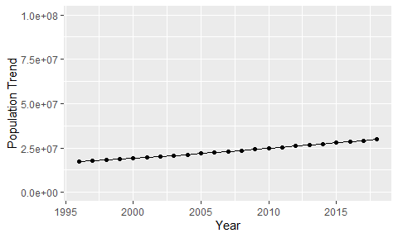

Political Stability Trend

# Population growth trend

The plot shows the population growth rate trend of the country.

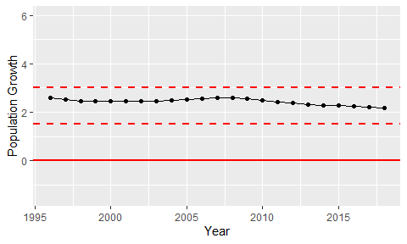

Population Growth Trend